Coding and Solution

|  |  |
| --- | --- |
| Team ID | PNT2022TMID45278 |
| Project Name | Real-time river water quality  monitoring and control system |

Debugging and Traceability

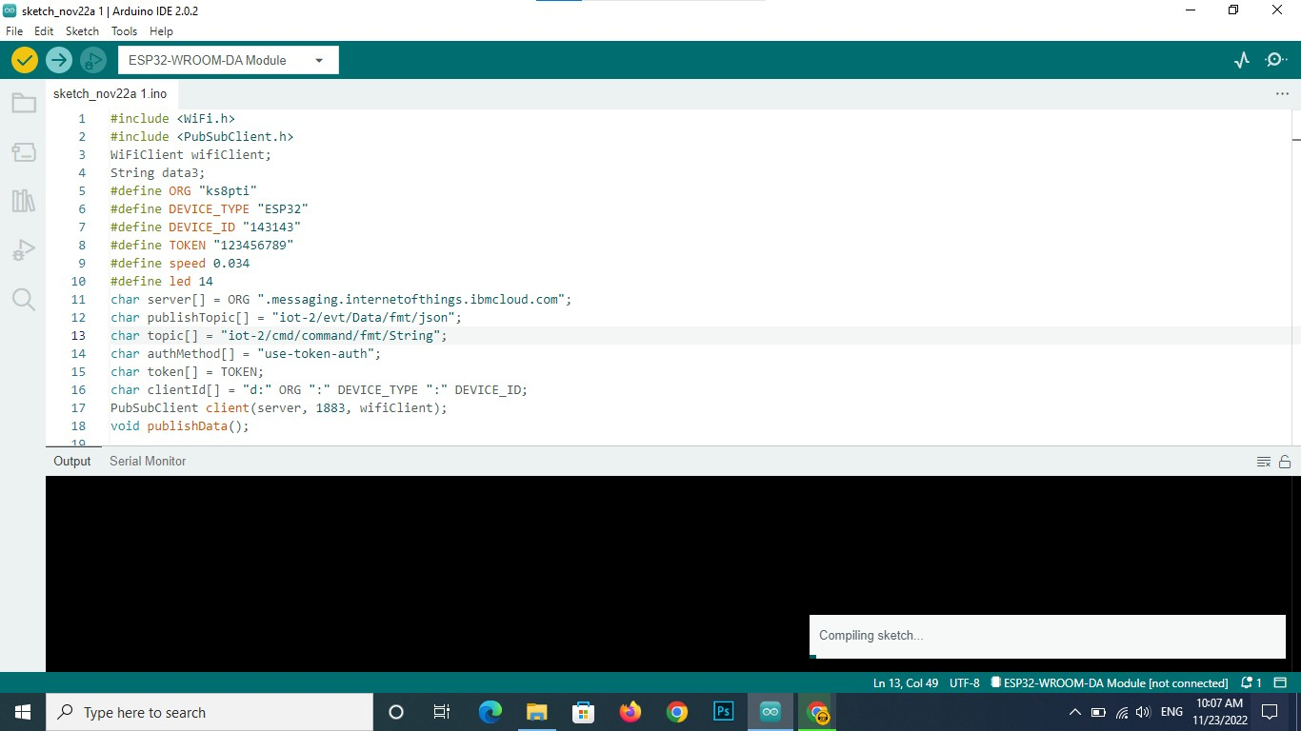

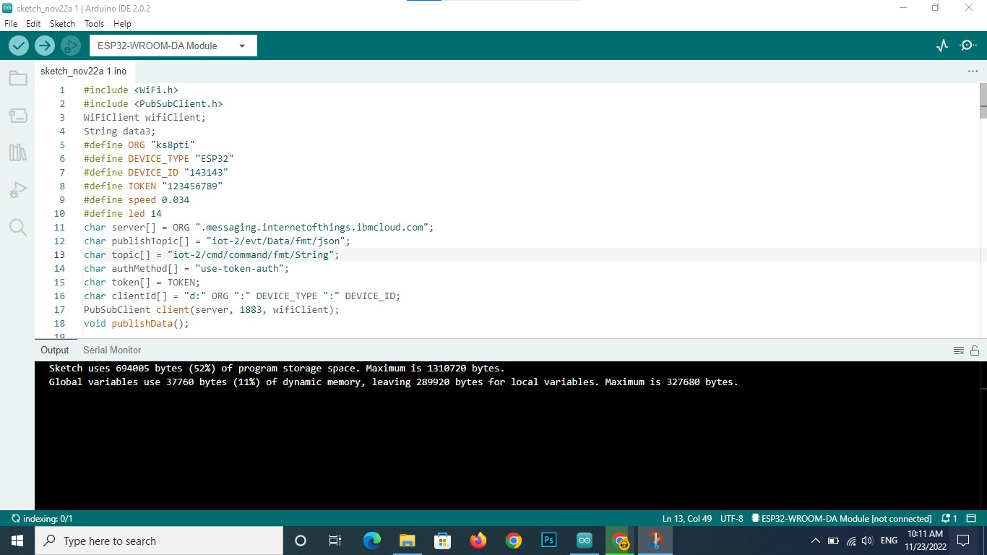

We are debug everything through the Arduino IDE